## Tech stack

### Data analysis

 

* Excel
* Python
* VS Code

### Data visualisation



* Tableau

## Skills showcased

Demonstrated 7 key skills through this micro experience

1. Web Scraping: Web scraping is used to extract relevant data from the RBI website for analysis and dashboard creation.
2. Data Cleaning and Transformation: Data cleaning and transformation are used to process and format the scraped data, ensuring its usability for analysis and visualization.
3. Data Preparation: Data preparation is utilized to organize, filter, and aggregate the scraped data, making it ready for visualization and analysis.
4. Data Visualization: Data visualization is employed to present the cleaned and aggregated data in a visually appealing and informative manner through interactive dashboards.
5. Business Analysis: Business analysis is utilized to identify key metrics, analyze performance trends, and provide actionable insights for decision-making.
6. Problem Solving: Problem-solving is applied to address challenges in data cleaning, visualization, and analysis to ensure accurate and reliable results.
7. Creativity: Creativity is employed in designing an engaging and user-friendly dashboard that effectively presents data insights in an innovative manner.

## Problem scenario

### Situation

**Business Situation:** HDFC Bank lacks a system to assess its performance relative to the industry, hindering decision-making and strategic planning.

**Business Process:** Create a comprehensive card usage dashboard to track key metrics and benchmark HDFC Bank's performance in the industry.

**Importance**: Understanding HDFC Bank's performance relative to the industry is crucial for informed decision-making and strategic planning.

### Complication

**Benchmarking:** Determining accurate industry benchmarks for comparison to assess HDFC Bank's performance.

**Data Interpretation:** Analyzing the collected data to extract meaningful insights and draw accurate conclusions.

**Decision-making:** Using the dashboard insights to make informed decisions and develop effective strategies for HDFC Bank's growth and competitiveness.

### Business impact

**Competitive Advantage:** Having a comprehensive understanding of HDFC Bank's performance relative to the industry allows for strategic decision-making, enabling the bank to gain a competitive advantage over its peers.

**Targeted Growth Strategies:** Accurate data-driven insights from the dashboard can help HDFC Bank identify areas of strength and weakness, allowing them to focus on specific growth strategies and improve performance in key metrics.

**Customer Satisfaction:** By analyzing customer behavior and trends, HDFC Bank can tailor its offerings and services to meet customer expectations, resulting in improved customer satisfaction and retention.

## Objectives

The objectives of creating the comprehensive dashboard for HDFC Bank are to assess market share, evaluate performance, analyze customer behavior, and support data-driven decision-making

.

## Approach

1. **Problem approach**
   1. **Data Scraping:** Use web scraping techniques to collect relevant data from the RBI website for analysis.
   2. **Data Cleaning:** Clean and transform the collected data to ensure accuracy and usability.
   3. **Dashboard Design:** Create an interactive and visually appealing dashboard to present key metrics and trends.
   4. **Performance Analysis:** Analyze the data to assess HDFC **Bank's standing within the industry and identify areas for improvement**.
2. **Analytical approach**
   1. **Data Aggregation:** Aggregate and summarize the collected data to calculate key performance indicators (KPIs) for analysis.
   2. **Comparative Analysis:** Compare HDFC Bank's performance against industry benchmarks to gauge relative standing.
   3. **Trend Analysis:** Track the month-on-month growth of KPIs to identify patterns and spot areas of improvement.
   4. **Top Performer Identification:** Identify top-performing banks based on selected KPIs to benchmark HDFC Bank's performance.
   5. **Insights Generation:** Extract meaningful insights from the analyzed data to provide actionable recommendations for strategic decision-making.
3. **Insights and recommendations**
   1. **Market Share Enhancement:** Identify opportunities to increase market share by leveraging customer behavior insights and targeted marketing strategies.
   2. **Performance** **Optimization:** Recommend improvements in specific KPIs, such as transaction volume or average transaction size, to enhance overall performance.
4. **Solution implementation and monitoring**
   1. **Solution Implementation:** Execute the recommended strategies, such as targeted marketing campaigns or process improvements, to drive desired outcomes.
   2. **Ongoing Monitoring:** Continuously track and evaluate the implemented solutions to ensure their effectiveness and make adjustments as needed for sustained performance improvement..
5. **Communication** 
   1. **Stakeholder Communication:** Effectively communicate insights, recommendations, and progress updates to stakeholders, ensuring alignment and transparency.
   2. **Data Visualization:** Use visualizations and storytelling techniques to present complex data in a clear and understandable manner for effective communication**.**

## Impact created

## By creating a comprehensive dashboard and implementing data-driven strategies, HDFC Bank can achieve a competitive edge, optimize performance, enhance customer satisfaction, and drive sustainable growth in the dynamic banking industry.

## Project deliverables

**D1_Scraping_Data_from_Web**

Link: https://github.com/aritra-18/HDFC-Bank-Performance-Insights-Dashboard/blob/main/D1_Web_Scraping_Datasets.ipynb

Type: Python Notebook

Extracting data from websites for analysis and insights generation.

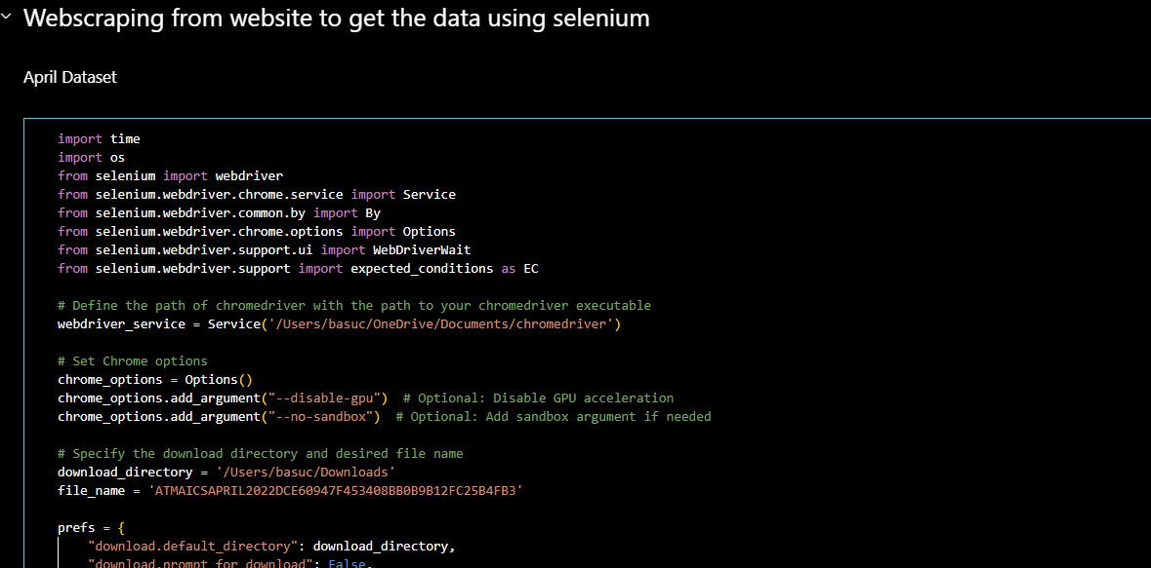

**D2_Data_Cleaning_and_Preparation**

Link: <https://github.com/aritra-18/HDFC-Bank-Performance-Insights-Dashboard/blob/main/D2_Data_Cleaning.png>

Type: Excel Spreadsheet

Preparing data for accurate analysis and visualization, ensuring data quality.

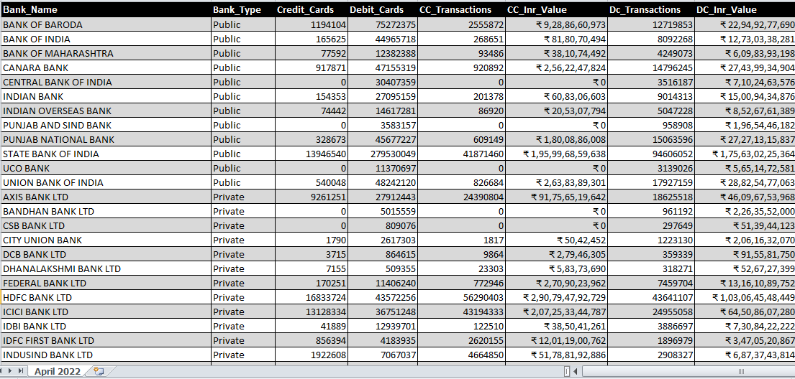

**D3_High_Level_View_Dashboard**

Link: <https://github.com/aritra-18/HDFC-Bank-Performance-Insights-Dashboard/blob/main/High_Level_View_Dashboard.png>

Type: Tableau Packaged Workbook

Provide a summary of key metrics for quick performance assessment.

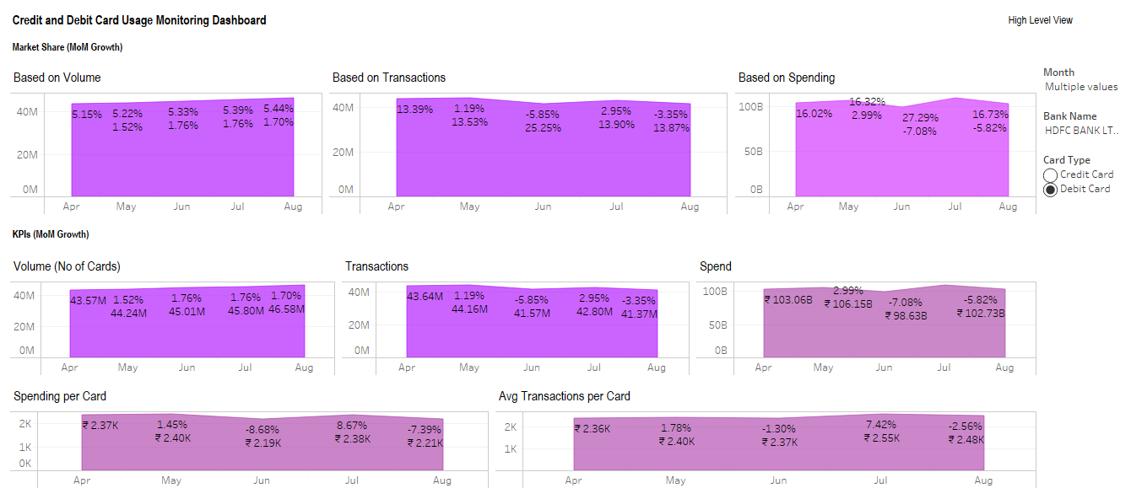

**D3_** **Market_Share_Analysis_Dashboard**

Link: <https://github.com/aritra-18/HDFC-Bank-Performance-Insights-Dashboard/blob/main/Market_Share_Analysis_Dashboard.png>

Type: Tableau Packaged Workbook

Analyze market share trends to assess competitive positioning accurately.

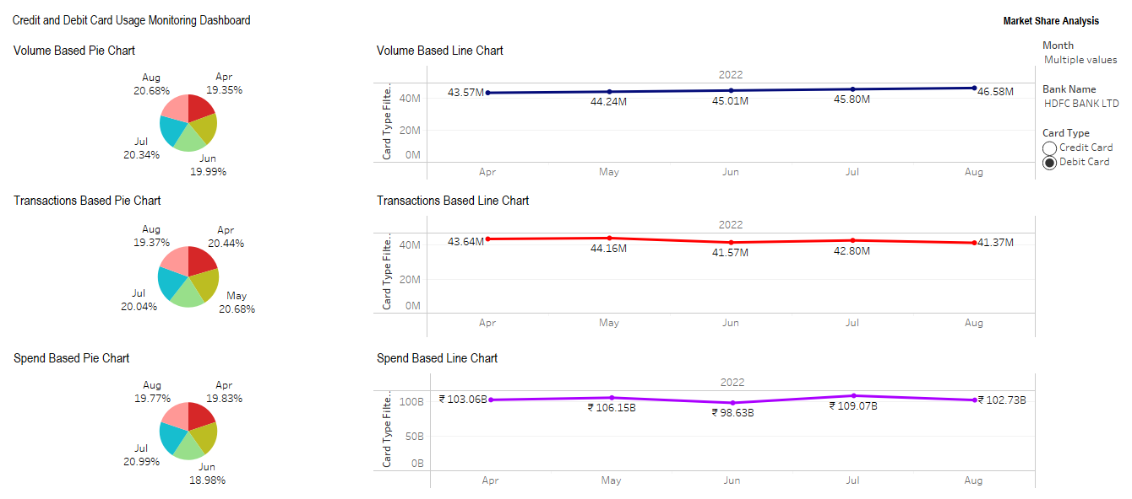

**D3_** **KPI_Analysis_Dashboard**

Link: <https://github.com/aritra-18/HDFC-Bank-Performance-Insights-Dashboard/blob/main/KPI_Analysis_Dashboard.png>

Type: Tableau Packaged Workbook

Analyze KPI trends to evaluate performance and identify improvement areas.

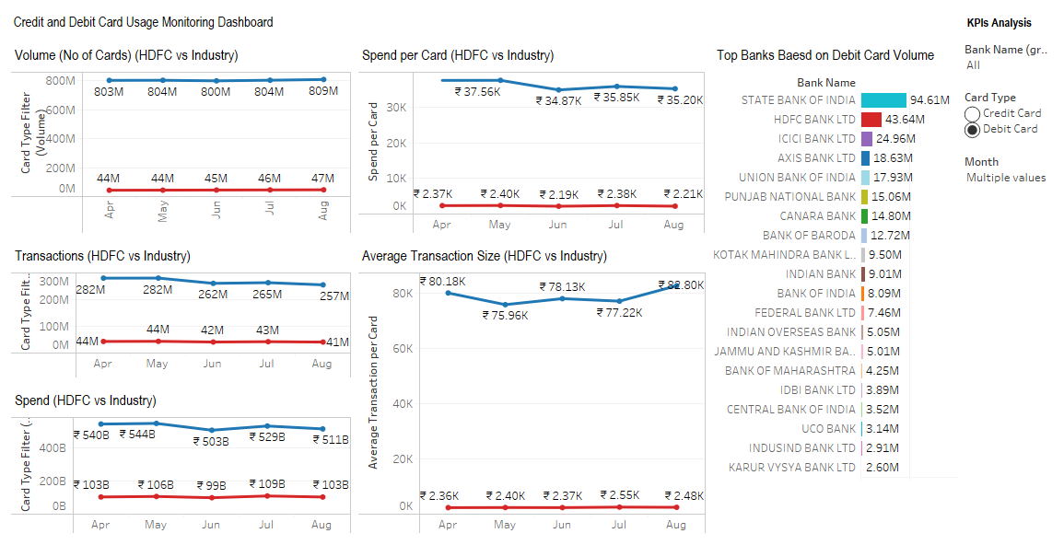

## Things I learnt (optional)

1. **Business Aspect:** Acquired insights into market dynamics, enabling data-driven decision-making and strategic planning for sustained competitiveness.

2. **Analysis Aspect:** Developed proficiency in data collection, cleansing, and visualization, enabling comprehensive analysis and insightful data-driven recommendations.

3. **Technical Aspect:** Gained hands-on experience with Python, Selenium, Excel, and Tableau, empowering efficient data scraping, manipulation, and interactive visualization for impactful insights.

## Feedback received (optional)

N/A